

September 10, 2023

Dear Friends and Family of Music,

This is Duo Shen, the Music Director of YOUR Grand Rapids Youth Symphony (GRYS) & Classical Orchestra (CO). It has been a great pleasure of mine to be able to work with some of the most talented and dedicated young musicians of the West Michigan. We have grown so much as a group and we made so many friends and created one big family along the way. Through this program, we nurture numerous young musicians to change the world for the better in their own unique ways.

With our world in so much pain, it is more important than ever to help the next generation to find a safe and helpful way to express themselves and connect with one another. I believe, music is the way!

I write to you today with two requests:

* The first is to join me in helping our community’s most talented young musicians grow their musical abilities and strengthen their connection to great art. We ask for your financial support twice a year, and if you haven’t helped us out this year, we would very much appreciate your generous contribution. You may refer to the brochure for more information. You may also use online giving at GRYS.ORG.
* The second is your attendance at our performances this season:
  + Sunday, November 19th, 2023, at 3 PM Northview High School and,
  + Sunday, February 25th, 2023, at 3 PM GR Christian High School Devos Center for Arts & Worship and,
  + Sunday, May 5th, 2023, at 3 PM at DeVos Performance Hall.

I invite you to join us in concert halls to listen to our amazing young musicians sharing their talent. And when you come, I ask you to bring a friend, a family member, or a young person, as I firmly believe in sharing the transformative power of music and that all humans can create a unique connection through music.

As I said from my last letter: It takes a village to raise a child, so I am humbly asking you to invest in our future, in our community and support these young talented musicians through your GRYS & CO, as well as our local schools. I have no doubt that in just a few years, these rising stars will help us make the world a better place!

Thank you for your support.

Sincerely,

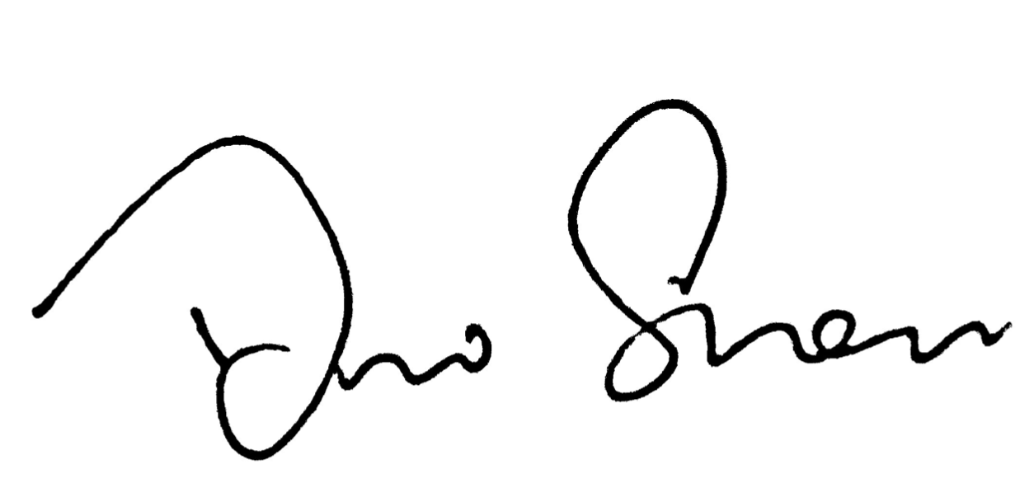

Duo Shen

Music Director, Grand Rapids Youth Symphony and Classical Orchestra

Assistant Conductor, Grand Rapids Symphony

*GRYS Manager: 57 Courtland Street Box 481, Rockford, Michigan 49341 616 842-6566*

*300 Ottawa Ave. N.W. Suite 100, Grand Rapids, Michigan 49503 616 454-9451*